**STAT 40001/STAT59800 Statistical Computing Fall 2020**

**Lab -17**

**Q.N. 1)** The more beer you drink, the more your blood alcohol level (BAL) rises. Table below contains a data set on beer consumption.

Beers 5 2 9 8 3 7 3 5 3 5

BAL 0.10 0.03 0.19 0.12 0.04 0.095 0.07 0.06 0.02 0.05

1. Make a scatterplot with a regression line

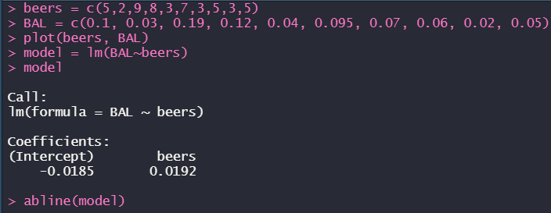

1. Calculate 95% confidence interval for the model parameters

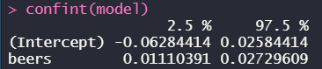

1. State the estimated linear regression model.

*BAL = -0.0185 + 0.0192 * beers*

**Q.N. 2)** A marketing researcher studied annual sales of a product that had been introduced 10 years ago. The data are as follows, where x is the year coded and y is the sales in thousands of units:

x: 0 1 2 3 4 5 6 7 8 9

y: 98 135 162 178 221 232 283 300 374 395

1. Prepare a scatter plot of the data

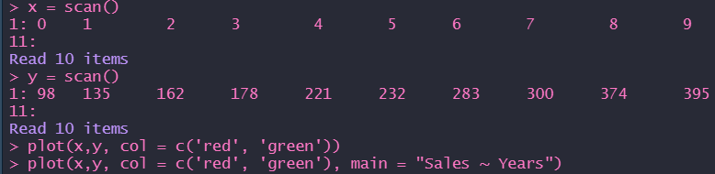

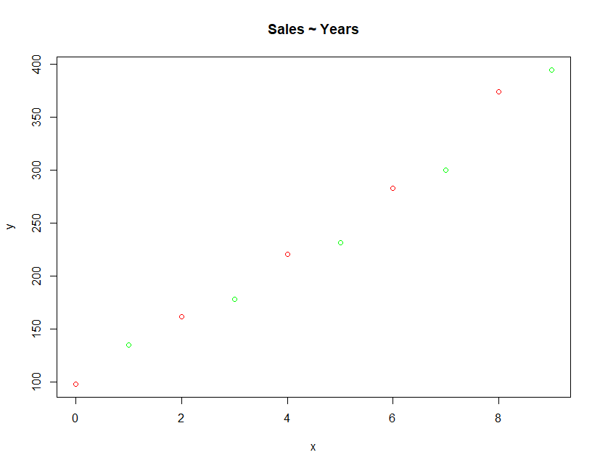

1. State the estimated regression line for the data and add it to the scatter plot.

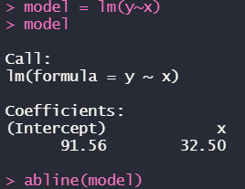

*(y = 91.56 + 32.5 * x)*

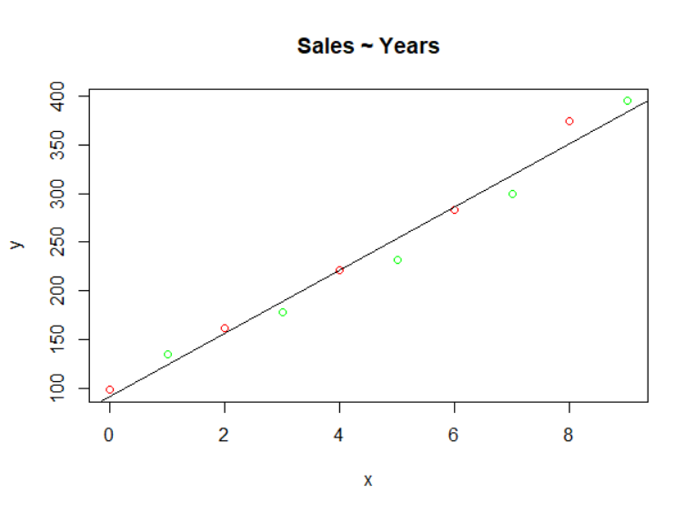

d) Use the model to predict the sales in the 10th year (i.e. For x=10). Also provide the 95% and 90% confidence interval for the predicted value.

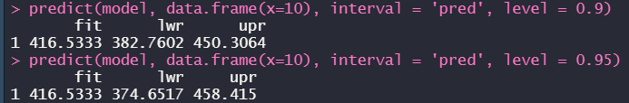

**Q.N. 3)** A simple random sample of apparently healthy children between the ages of 6 months and 15 years yielded the following data on age, X, and liver volume per unit of body weight (ml/kg), Y

|  |  |  |  |  |  |  |  |  |  |  |  |  |  |  |  |
| --- | --- | --- | --- | --- | --- | --- | --- | --- | --- | --- | --- | --- | --- | --- | --- |
| X | 0.5 | 0.7 | 2.5 | 4.1 | 5.9 | 6.1 | 7 | 8.2 | 10 | 10.1 | 10.9 | 11.5 | 12.1 | 14.1 | 15 |
| Y | 41 | 55 | 41 | 39 | 50 | 32 | 41 | 42 | 26 | 35 | 25 | 31 | 31 | 29 | 23 |

1. Prepare a scatter plot of the data

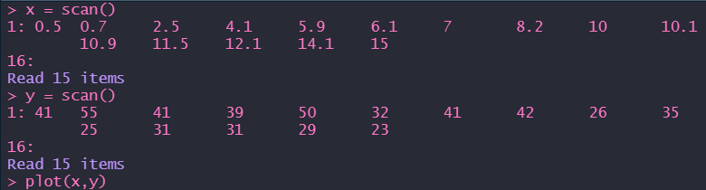

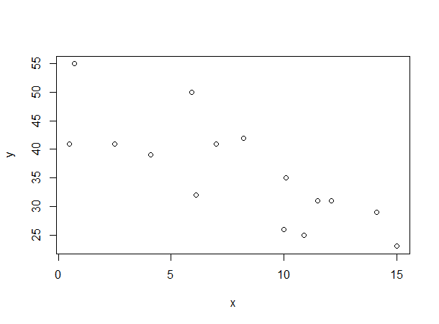

1. State the estimated regression line for the data and add it to the scatter plot.

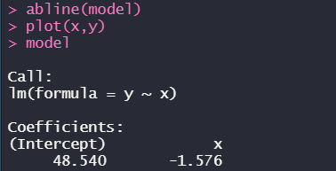

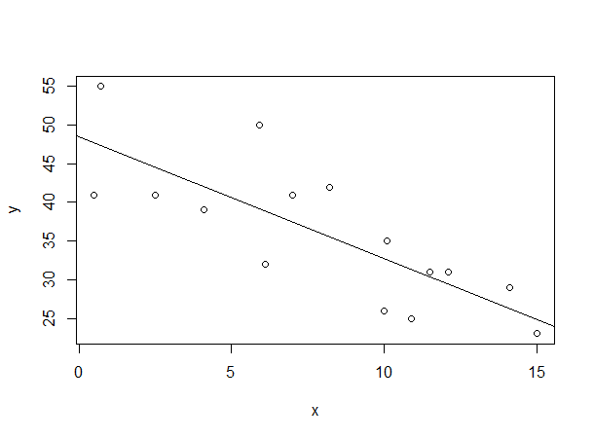

*(y = 48.54 – 1.576 * x)*

1. Use the model to predict the liver volume of 8 years old child.



1. Construct a 90% Confidence interval for the predicted value of the liver volume of 8 years old child



1. Construct a 90% prediction interval for the predicted value of the liver volume of 8 years old child

